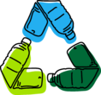
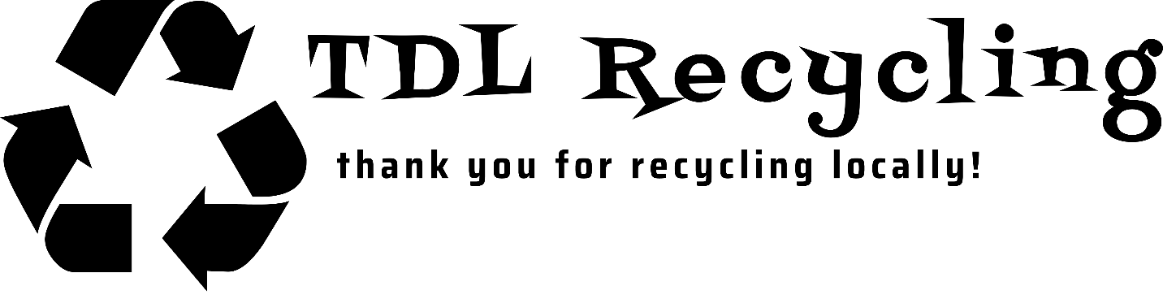
Forest Lakes

Phone: 970.749.4762
Email: tdlrecycling@gmail.com
Website: www.tdlrecycling.com
Name: _________________________________________________

Date: _______________________________________

Service Address: __________________________________________________

Email: ____________________________________________

City, State, Zip: __________________________________________________

Daytime Phone Number: __________________________________________________

By signing below, I authorize TDL Recycling LLC to invoice me on a monthly basis for the amount of $12. I understand that failure to pay may result in the discontinuation of my service.

I also agree to only place accepted recycling materials in the poly-cart provided for recycling and understand that placement of non recyclable material or hazardous material may result in discontinuation of service.

Signature:

__________________________________

